**RUNWAY READY**

**AN AUCTION PLATFORM**

A MINI PROJECT REPORT

*Submitted by*

**Project group-G22**

**VIVEK BHATT, 2310992562**

**VRINDA GARG, 2310992563**

**YASH CHAUHAN, 2310992564**

***in partial fulfillment for the award of the degree of***

**BACHELOR OF ENGINEERING**

***in***

COMPUTER SCIENCE &

ENGINEERING

**CHITKARA UNIVERSITY**

**CHANDIGARH-PATIALA**

**NATIONAL HIGHWAY RAJPURA**

**(PATIALA) PUNJAB-140401 (INDIA)**

DECEMBER,2023

**ABSTRACT**

The advent of digital technologies has revolutionized traditional commerce, prompting a shift towards online platforms. This project introduces an innovative online auction platform designed to facilitate seamless and dynamic bidding processes. The platform is developed using HTML, CSS, and JavaScript, harnessing the power of modern web technologies to create an engaging and user-friendly experience.

**Objectives:**

1. Efficient Auction Management: The platform aims to streamline the auction process.

2. User Engagement: Focus is placed on enhancing user engagement through an intuitive interface, real-time updates, and interactive bidding mechanisms.

**Features:**

1. Item Listing: Sellers can easily list their items, complete with detailed descriptions, images, and starting bid prices.

2. Real-time Bidding: Utilizing JavaScript, the platform enables real-time bidding, providing users with instant updates on current bid status.

3. Responsive Design: The platform is designed to be accessible and responsive across various devices, ensuring a consistent user experience.

**Technological Stack:**

1. HTML and CSS: Used for structuring and styling the web pages, providing an aesthetically pleasing and consistent interface.

2. JavaScript: Employed to create dynamic and interactive elements, facilitating real-time bidding and enhancing overall user experience.

**TABLE OF CONTENT**

|  |  |  |
| --- | --- | --- |
| **Sr. No.** | **Section** | **Page No.** |
| **1.** | Introduction | 1 |
| **2.** | Problem Statement | 2 |
| **3.** | Technical Details | 3 |
| **4.** | Key Features | 4 |
| **5.** | Project Advantages | 5 |
| **6.** | Results | 6 |
| **7.** | Conclusion | 9 |
| 8. | References | 10 |

**1.INTRODUCTION**

In the ever-evolving landscape of digital commerce, the emergence of online auction platforms has redefined the dynamics of buying and selling, providing a virtual marketplace where users can engage in dynamic bidding processes from the comfort of their homes. This project introduces a cutting-edge online auction platform, meticulously crafted using HTML, CSS, and JavaScript to deliver an immersive and efficient bidding experience.

**Project Objectives:**

1. Efficient Auction Management: The primary goal is to create a streamlined auction management system, offering sellers and buyers a robust platform for listing items, placing bids, and managing auctions seamlessly.

2. Enhanced User Engagement: With a focus on user experience, the platform aims to captivate users through an intuitive interface, real-time updates, and interactive bidding mechanisms, fostering a sense of community and excitement.

3. Security and Trust: Implementing stringent security measures is a core objective, ensuring the confidentiality of user information, the integrity of financial transactions, and overall user trust in the platform.

**Technological Foundation:**

The technological backbone of this project relies on HTML and CSS for structuring and styling, creating a visually appealing and consistent user interface. JavaScript, with its dynamic capabilities, plays a pivotal role in enabling real-time bidding, thus enhancing the platform's responsiveness and interactivity.

**2.PROBLEM STATEMENT**

Runway Ready aims to address several fundamental problem statements within the realm of buying and selling second-hand items in online marketplaces.

First and foremost, it focuses on trust and transparency, mitigating concerns related to raud and misrepresentation. By providing verified seller profiles, secure payment options, and detailed item descriptions, Runway Ready ensures users can participate in transactions with confidence.

Moreover, the platform simplifies the user experience, eliminating the complexity often associated with online marketplaces. It provides an intuitive and user-friendly interface, making it accessible to a broad range of users, from tech-savvy individuals to those new to e-commerce.

Security is a paramount concern, and Runway Ready addresses it by implementing stringent privacy measures and safeguarding user data, including payment information.

The real-time bidding feature, powered by JavaScript, adds an interactive and competitive edge to auctions, bringing back the excitement of traditional auctions in an online format.

Additionally, personalized item recommendations streamline the process of finding the right items, making it easier for buyers to discover treasures that match their interests and style.

In summary, Runway Ready resolves key problem statements, providing a trustworthy, user-friendly, secure, and engaging platform for the buying and selling of second-hand items, where style meets simplicity.

**3.TECHINCAL DETAILS**

**1.HTML**

HTML, or Hyper Text Markup Language, is the standard markup language for creating and structuring web pages. It provides a way to describe the structure of a document semantically and includes elements to represent headings, paragraphs, links, images, forms, and other types of content. HTML is a crucial technology for building and designing websites.

HTML TAGS USED:

1.`<html>`:

The root element that wraps the entire HTML document.

2.`<head>`:

Contains meta information, links to external resources, and the page title.

3.`<meta>`:

Provides metadata about the HTML document, such as character encoding and viewport settings.

4.`<title>`:

Sets the title of the web page displayed in the browser tab.

5.`<link>`:

Links to external resources, like CSS files.

6.`<style>`:

Contains internal CSS styles for the page.

7.`<body>`:

The main content area of the web page.

8.`<header>`:

The header section of the website.

9.`<nav>`:

Contains navigation links.

10.`<div>`:

A generic container for structuring and styling content.

11.`<div>:

Used to create navigation links.

12.`<h1>`, `<h2>`, `<h3>`, `<h4>`:

Headings of various levels for structuring content.

13.`<p>`:

Paragraphs for text content.

14.`<section>`:

Divides the content into sections, such as the hero section and featured auctions.

15.`<a>`:

Anchor tags used for hyperlinks.

16.`<img>`:

Embeds images in the page.

**2.CSS**

CSS, or Cascading Style Sheets, is a style sheet language used for describing the presentation of a document written in HTML or XML. It defines how elements on a web page should be displayed, including their layout, colors, fonts, and other visual aspects. CSS enables web developers to separate the structure and content of a document from its visual presentation, making it easier to maintain and update the styling of a website.

CSS STYLES USED:

1.CSS Reset:

Styles to reset some default browser styles using the * selector.

2.Font Styling:

Custom fonts imported from Google Fonts for headings and body text.

3.Background Colors:

Background colors defined for the header, hero section, and footer.

4.Text Styling:

Font size, colors, and text alignment for various elements.

5.Box Model:

Styles for padding, margins, and border-radius for layout and element spacing.

6.Layout:

Styles for creating a responsive layout using Flexbox or CSS Grid, as well as media queries for responsiveness.

7.Hover Effects:

Transition effects for links and buttons to change appearance on hover.

8.Image Styling:

Max-width and height for images to ensure responsive behavior.

9.Box Shadow:

Adds a subtle shadow to elements like buttons etc.

10.Animation:

Hover animations for buttons and more using the :hover pseudo-class.

11.Transition:

Manages all the transition timing and other features like time delay etc.

12.Display-flex:

Controls the layout, alignment, and behavior of the flex items within the flex container. These properties provide powerful tools for creating responsive and flexible layouts in CSS.

13.Scale:

This function is used to scale elements in two or three dimensions. It's a transformation function that changes the size of an element without affecting its proportions. The scale() function takes one or two parameters, representing the scaling factor for the x and y axes respectively.

14.Selection:

This pseudo-element is used to style the portion of a document that is highlighted or selected by the user. This feature allows you to define custom styles for the selected text, such as changing its background color, text color, or any other applicable properties.

15. *:

The asterisk (*) is known as the universal selector. It matches any element type and is used to apply styles to all elements within a document or to target specific elements more broadly.

16.Font-family:

This property in CSS is used to specify the preferred font(s) for text content within HTML elements. It allows you to define a list of font choices that the browser will use to display text, and if the first font is not available, it will try the next one in the list, and so on.**JAVA SCRIPT**

JavaScript, often abbreviated as JS, is a high-level, interpreted programming language that plays a crucial role in web development. Developed primarily for enhancing the interactivity of web pages, JavaScript is a versatile language used both on the client side (in web browsers) and, with the advent of technologies like Node.js, on the server side as well.

JS USED:

1. Navigation Toggle:

- Enhances user experience on mobile devices.

2. Interactive Features:

- Enhances overall interactivity and user engagement.

3. Integration with HTML and CSS:

- Ensures a clean separation of concerns by integrating seamlessly with HTML and CSS.

- JavaScript enhancements complement the structure provided by HTML and the styling provided by CSS.

4. Responsive Design:

- Contributes to a responsive design.

- Adapts to different screen sizes, improving the user experience on various devices.

**4.KEY FEATURES**

Key Features of the Runway Ready Auction Website:

1.User Registration and Authentication: Users can create accounts and log in securely. This allows them to access personalized features, track their bids, and manage their auctions.

2.Product Listings: Sellers can list accessories for auction. Each listing includes detailed product information, images, and bidding options.

3.Auction Bidding: Registered users can place bids on listed items. The system handles real-time bidding, updating the current bid amount, and notifying users of competing bids.

4.Featured Auctions: The platform highlights featured auctions on the homepage to attract user attention to select items.

5.User Dashboard: Users can access a personalized dashboard where they can view their active bids, watchlist items, and transaction history.

6.Search and Filter: Users can search for specific items and filter results based on categories, price range, and other parameters.

7.Performance Optimization: To provide a fast and efficient experience, the site is optimized for performance through techniques like image compression and code minification.

8.Custom Styling: The site features custom styling, creating a visually appealing and unique user interface.

**5.PROJECT ADVANTAGES IN FUTURE**

1.Making Money: For those who create the platform, it can be a way to make a lot of money. They can earn money when people list items for sale and when auctions are successful.

2.More Customers: Many people who love fashion and unique items can use this platform. This means more people can join and use it, which is good for the business.

3.Enjoyable Experience: Users will like the platform because they can bid in real time, talk to sellers, and keep track of their activity. It will make users happy, and they will keep using it.

4.Trustworthy: Over time, the platform will become a trusted place for fashion auctions. People will know it's a good place to buy and sell fashion items.

5.Learning from Data: The platform can use data to learn about what people like and don't like. This information helps make the platform better in the future.

6.Helping the Earth: By promoting the reuse of fashion items, the platform can help the environment. It's good for the planet.

7.Unique Items: The platform can be known for selling unique and vintage fashion items. This attracts people who want special and one-of-a-kind things

**6.RESULTS**

1.More Users: Many people will use the website, and more will join over time. This is good because it means lots of people will be using the website.

2.Trusted Place: As time goes on, people will trust the website to buy and sell fashion items. It becomes a place where people know they can do business safely.

3.Helping the Environment: By using the website, people can help the planet by reusing things instead of throwing them away. It's good for the Earth.

4.Unique Items: The website can be known for selling special and old-fashioned fashion items. This attracts people who want something that's different from what everyone else has.

5.Lots of Users Worldwide: Since the website is online, people from all around the world can use it. It can become a big place for fashion lovers.

6.Famous and Important: By working with famous people and organizations, the website can become even more important in the fashion world.

7.Make Friends: People can make friends and talk to each other. It's like a group where they feel like they belong.

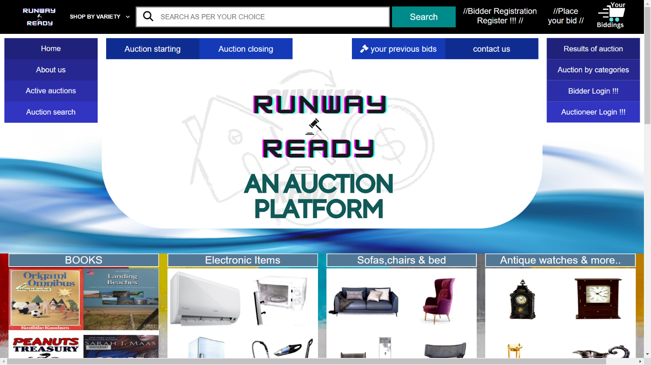

Figure 6. 1:Main page

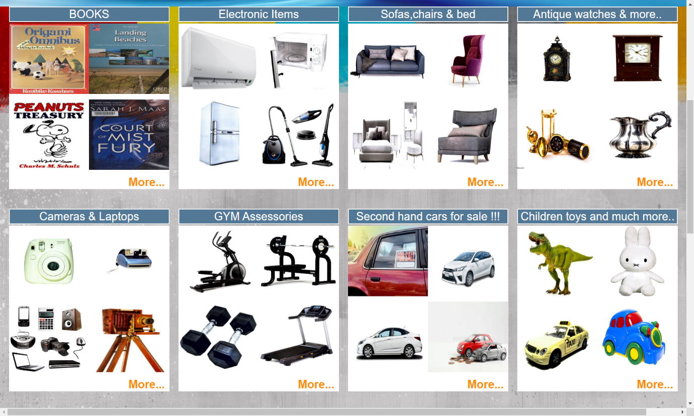

Figure 6. 2:Categories section



Figure 6. 3:Bottom sign-in Button

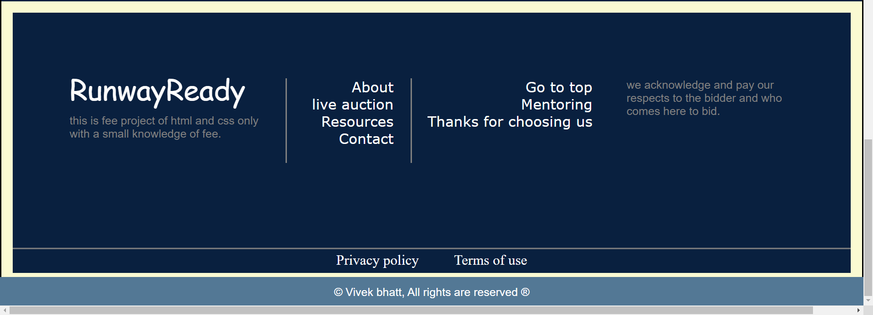

Figure 6. 4:Footer section



Figure 6. 5:Main nav

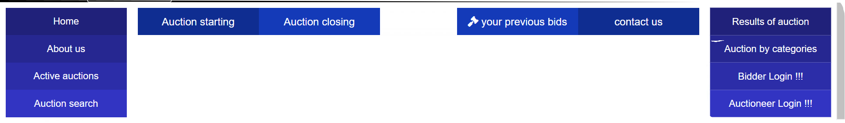

Figure 6. 6: Other nav’s

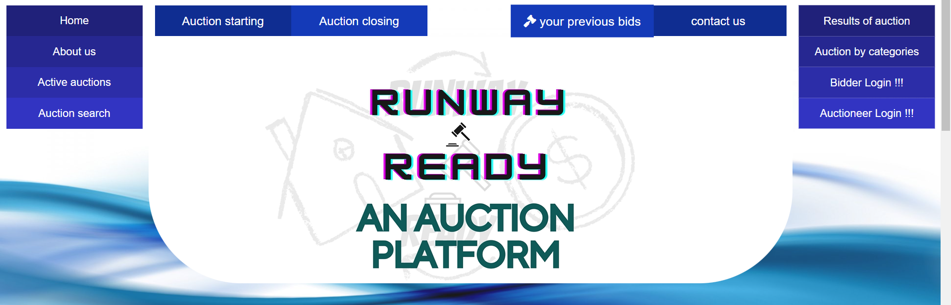

Figure 6. 7:Video embedded at centre of all nav’s

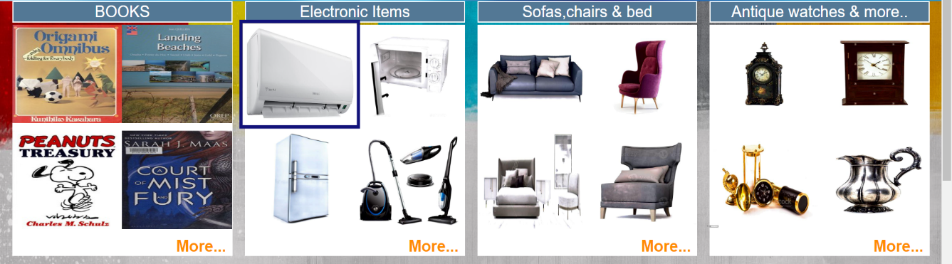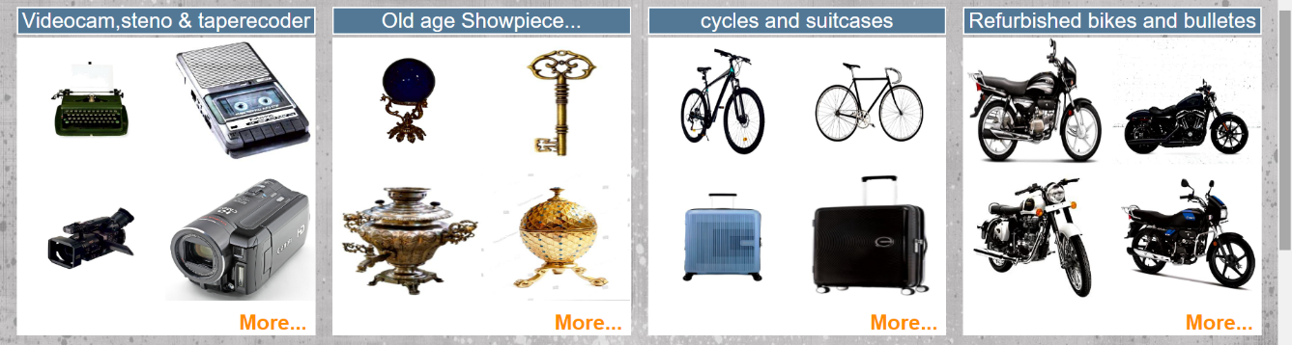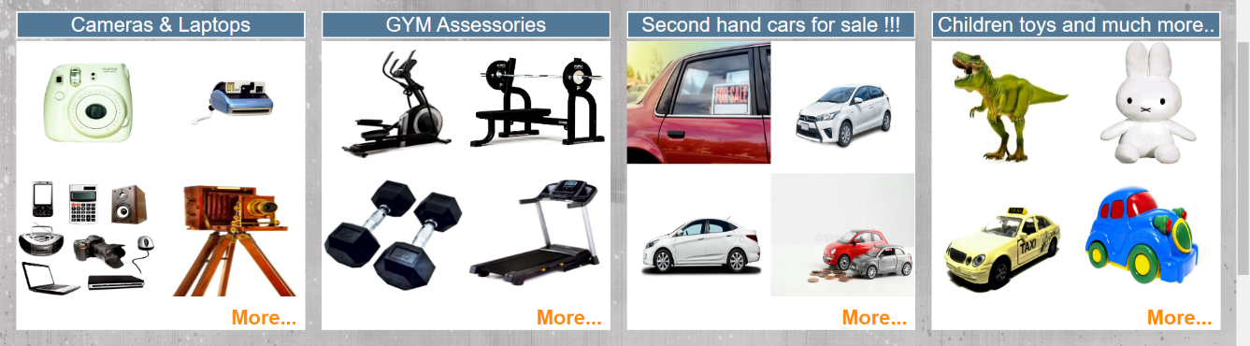

Figure 6. 8:Categories section full image

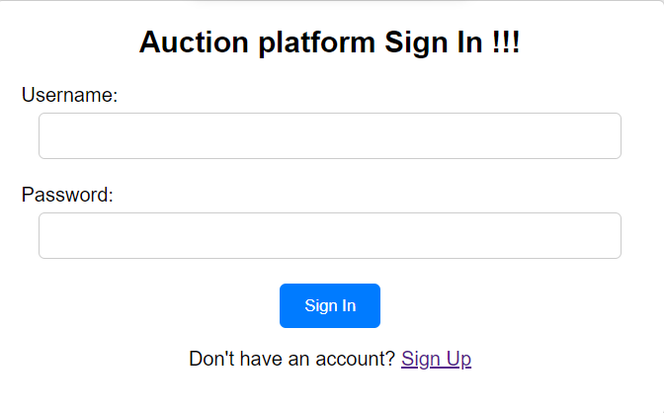

Figure 6.9: When we click on bottom sign in button

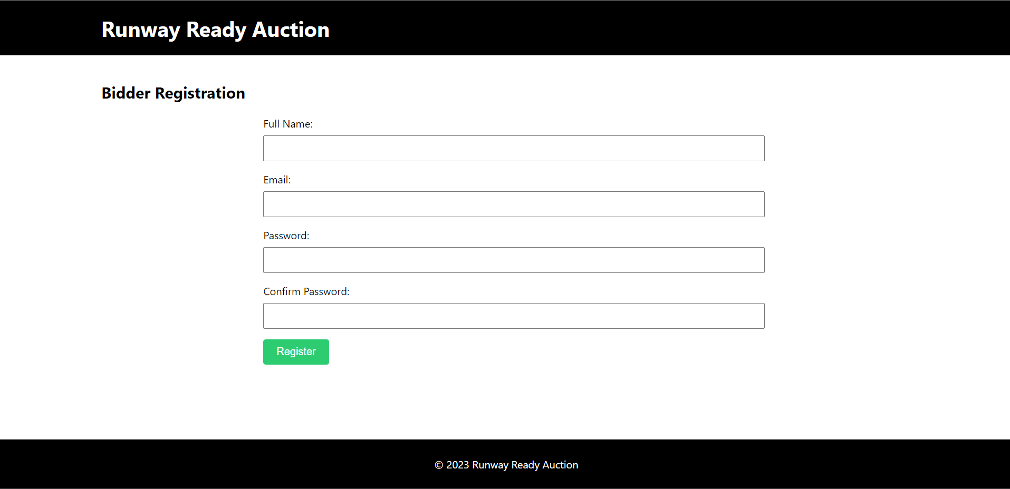

Figure 6. 10: when we click on main nav (bidder registration) button

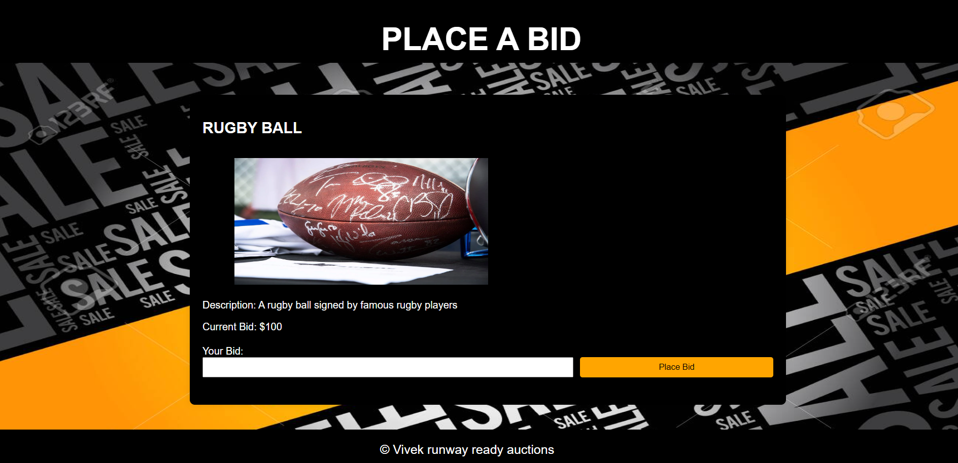

Figure 6. 11: when we click on main nav (place your bid) button

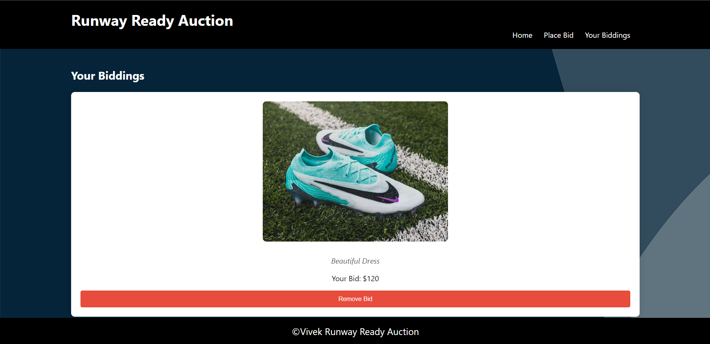

Figure 6. 12: when we click on main nav (your biddings) button



Figure 6. 13 when we use our website in small laptops it’s all nav’s become disable and all nav content goes to a button which is at the left top.

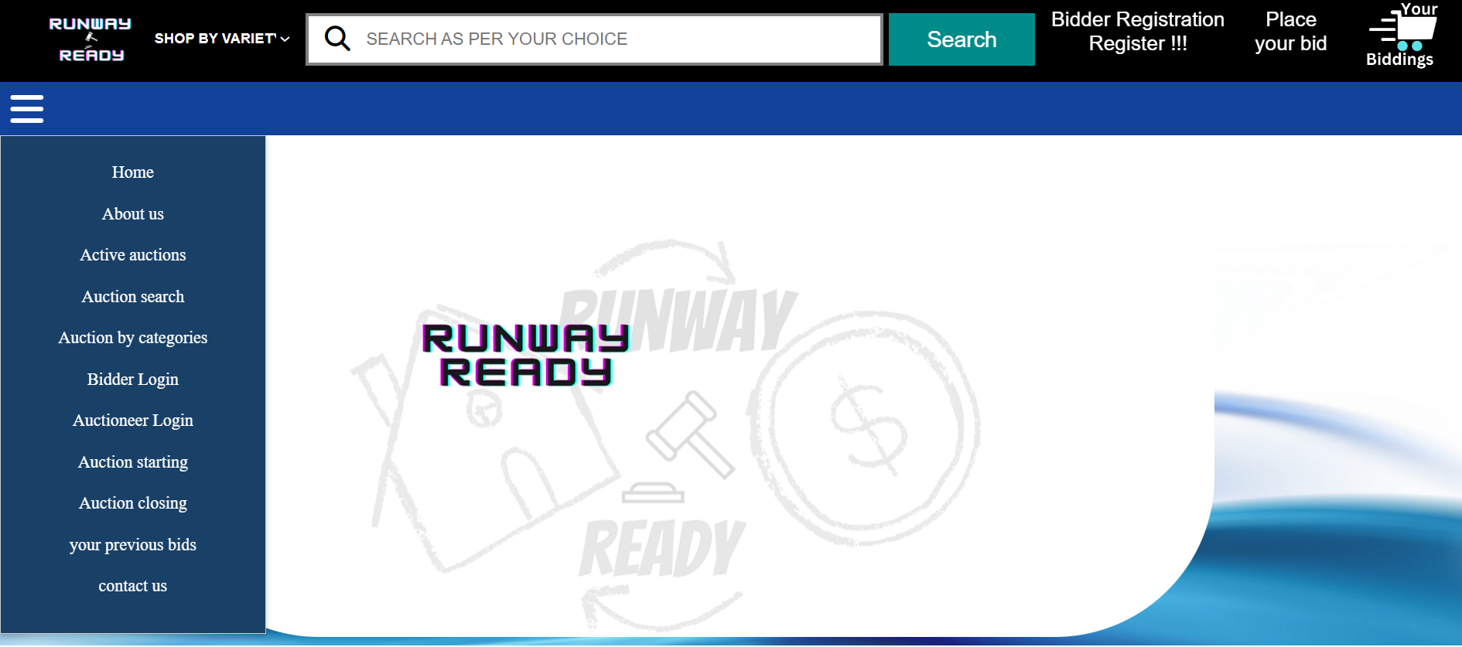

6. 14: when we click on the menu bar button this pop up opened

**7.CONCLUSION**

- The "Runway Ready" website excels in integrating HTML, CSS, and JavaScript to create a cohesive and visually appealing platform.

- HTML5 provides a solid foundation for semantic content structuring, ensuring accessibility and proper hierarchy.

- CSS styles, organized externally, contribute to a responsive design, enhancing the website's visual aesthetics and adaptability across devices.

- JavaScript is instrumental in implementing a responsive navigation toggle, improving user experience, particularly on mobile devices.

- The collaboration between HTML, CSS, and JavaScript demonstrates a clean separation of concerns, promoting maintainability and readability.

- Overall, "Runway Ready" achieves a harmonious blend of aesthetics and functionality, positioning itself at the forefront of contemporary web development practices.

**REFERENCES/LINKS**

1.<https://fontawesome.com/icons>

2.<https://www.canva.com/design/DAF2LuB_ujY/4E61wo2YxdnGdMs_pmEKgQ/edit?ui=eyJHIjp7fX0>

3.<https://in.pinterest.com/search/pins/?q=auction%20website%20items%20images&rs=typed>